MINISTERUL EDUCAȚIEI AL REPUBLICII MOLDOVA

UNIVERSITATE DE STAT “A. RUSSO”

FACULTATEA DE ȘTIINȚE REALE, ECONOMICE SI ALE MEDIULUI

**LUCRUL INDIVIDUAL**

**“ARHITECTURA ȘI ORGANIZAREA CALCULATORULUI”**

Student: Samciucov Valentin

Grupa: IS21Z

|  |  |  |  |
| --- | --- | --- | --- |
| **Nr.**  **d/o** | **NUME, PRENUME** | **GRUPA** | **VARIANTA** |
| 17 | Samciucov Valentin | IS21Z | 17 |

**SARCINA 1.**

|  |  |  |  |  |  |  |  |  |
| --- | --- | --- | --- | --- | --- | --- | --- | --- |
| **Nr** | **a** | **b** | **c** | **d** | **($\overline{ab}$ + 𝑐𝑑)** | **𝑎𝑏 $\overline{c}$** | $$\overline{abcd}$$ | **F(a, b, c, d)** |
| **0.** | 0 | 0 | 0 | 0 | 1 | 0 | 1 | 1 |
|  | 0 | 0 | 0 | 1 | 1 | 0 | 1 | 1 |
|  | 0 | 0 | 1 | 0 | 1 | 0 | 1 | 1 |
|  | 0 | 0 | 1 | 1 | 1 | 0 | 1 | 1 |
|  | 0 | 1 | 0 | 0 | 1 | 0 | 1 | 1 |
|  | 0 | 1 | 0 | 1 | 1 | 0 | 1 | 1 |
|  | 0 | 1 | 1 | 0 | 1 | 0 | 1 | 1 |
|  | 0 | 1 | 1 | 1 | 1 | 0 | 1 | 1 |
|  | 1 | 0 | 0 | 0 | 1 | 0 | 1 | 1 |
|  | 1 | 0 | 0 | 1 | 1 | 0 | 1 | 1 |
|  | 1 | 0 | 1 | 0 | 1 | 0 | 1 | 1 |
|  | 1 | 0 | 1 | 1 | 1 | 0 | 1 | 1 |
|  | 1 | 1 | 0 | 0 | 0 | 1 | 1 | 1 |
|  | 1 | 1 | 0 | 1 | 0 | 1 | 1 | 1 |
|  | 1 | 1 | 1 | 0 | 0 | 0 | 1 | 1 |
|  | 1 | 1 | 1 | 1 | 1 | 0 | 0 | 1 |

**Concluzii:** Rezultatele din tabel coincid cu datele din convertorul logic (Figura 1.)

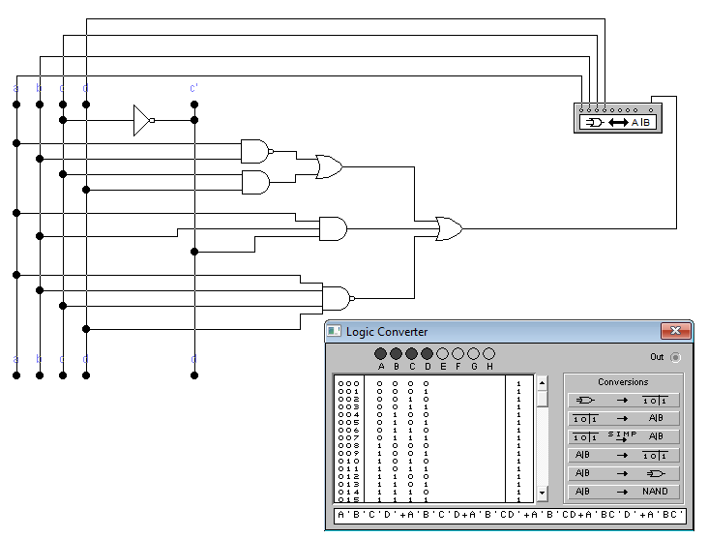

Figura 1. Schema electrică a dispozitivului conform funcției din sarcina 1.

**SARCINA 2.**

𝑓(𝑎, 𝑏, 𝑐, 𝑑, 𝑒) = ( 𝑎̅ + 𝑏 + 𝑐̅ + 𝑑̅ + 𝑒̅)( 𝑎̅ + 𝑏 + 𝑐̅ + 𝑑 + 𝑒̅)

( 𝑎̅ + 𝑏 + 𝑐 + 𝑑̅ + 𝑒̅)( 𝑎̅ + 𝑏 + 𝑐 + 𝑑̅ + 𝑒)( 𝑎̅ + 𝑏 + 𝑐 + 𝑑 + 𝑒̅)

|  |  |  |  |  |  |  |
| --- | --- | --- | --- | --- | --- | --- |
| **Nr** | **a** | **b** | **c** | **d** | **e** | **Max** |
| **0.** | 0 | 0 | 0 | 0 | 0 | 0 |
|  | 0 | 0 | 0 | 0 | 1 | 0 |
|  | 0 | 0 | 0 | 1 | 0 | 0 |
|  | 0 | 0 | 0 | 1 | 1 | 0 |
|  | 0 | 0 | 1 | 0 | 0 | 0 |
|  | 0 | 0 | 1 | 0 | 1 | 0 |
|  | 0 | 0 | 1 | 1 | 0 | 0 |
|  | 0 | 0 | 1 | 1 | 1 | 0 |
|  | 0 | 1 | 0 | 0 | 0 | 0 |
|  | 0 | 1 | 0 | 0 | 1 | 0 |
|  | 0 | 1 | 0 | 1 | 0 | 0 |
|  | 0 | 1 | 0 | 1 | 1 | 0 |
|  | 0 | 1 | 1 | 0 | 0 | 0 |
|  | 0 | 1 | 1 | 0 | 1 | 0 |
|  | 0 | 1 | 1 | 1 | 0 | 0 |
|  | 0 | 1 | 1 | 1 | 1 | 0 |
|  | 1 | 0 | 0 | 0 | 0 | 0 |
|  | 1 | 0 | 0 | 0 | 1 | 1 |
|  | 1 | 0 | 0 | 1 | 0 | 1 |
|  | 1 | 0 | 0 | 1 | 1 | 1 |
|  | 1 | 0 | 1 | 0 | 0 | 0 |
|  | 1 | 0 | 1 | 0 | 1 | 1 |
|  | 1 | 0 | 1 | 1 | 0 | 0 |
|  | 1 | 0 | 1 | 1 | 1 | 1 |
|  | 1 | 1 | 0 | 0 | 0 | 0 |
|  | 1 | 1 | 0 | 0 | 1 | 0 |
|  | 1 | 1 | 0 | 1 | 0 | 0 |
|  | 1 | 1 | 0 | 1 | 1 | 0 |
|  | 1 | 1 | 1 | 0 | 0 | 0 |
|  | 1 | 1 | 1 | 0 | 1 | 0 |
|  | 1 | 1 | 1 | 1 | 0 | 0 |
|  | 1 | 1 | 1 | 1 | 1 | 0 |

FCNC -> 𝑓(𝑎, 𝑏, 𝑐, 𝑑, 𝑒) = ( 17, 18, 19, 21, 23)

FCND -> 𝑓(𝑎, 𝑏, 𝑐, 𝑑, 𝑒) = (0, 1, 2, 3, 4, 5, 6, 7, 8, 9, 10, 11, 12, 13, 14, 15, 16, 20, 22, 24, 25, 26, 27, 28, 29, 30, 31)

**SARCINA 3.**

**Varianta 17. Codul 11100**

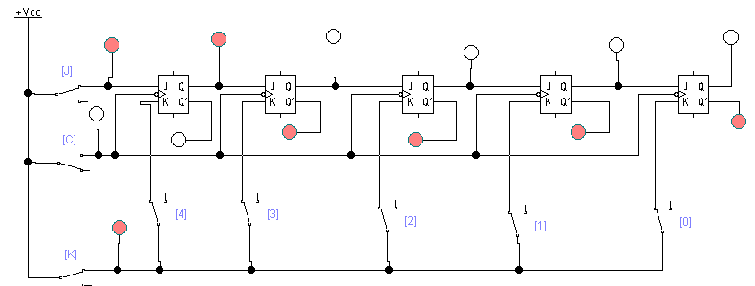

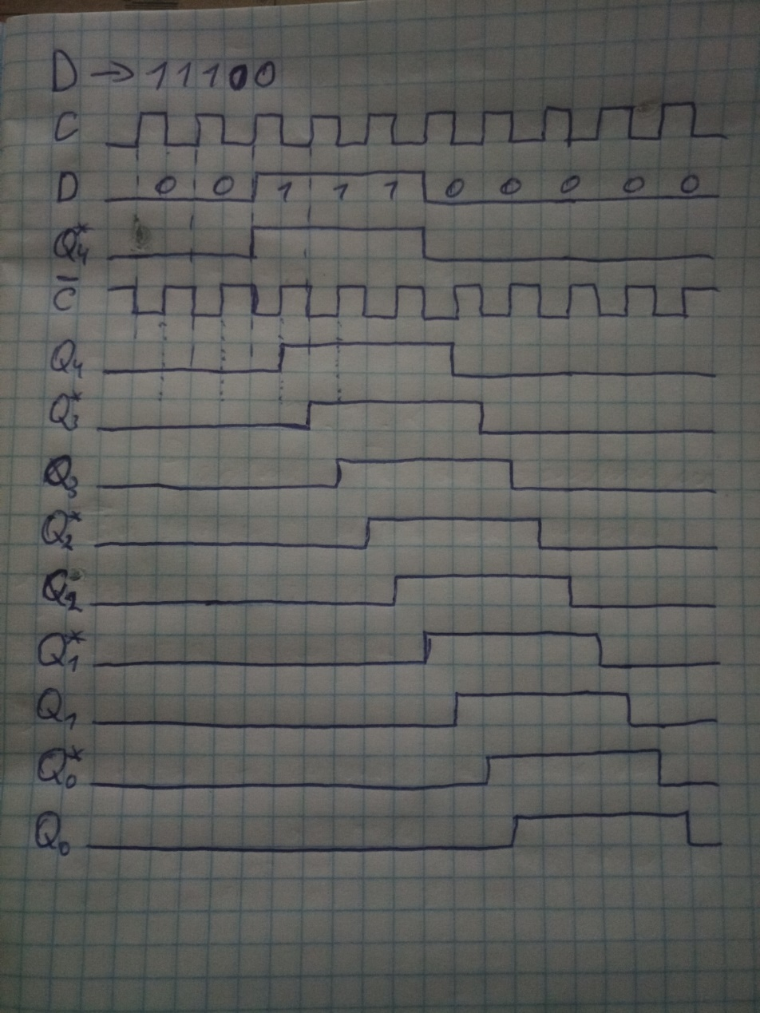

Fig 2. Diagramele temporale pentru cazul inscrierii codului 11100

**SARCINA 4.**

|  |  |
| --- | --- |
| Varianta | Modulul de numărare M |
| 17. | 111100 |

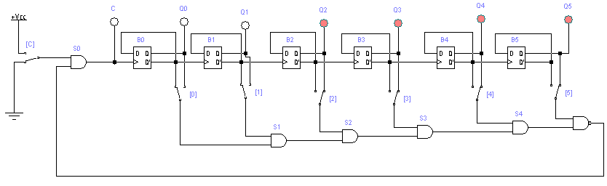

**SARCINA 5.**

|  |  |  |  |  |  |
| --- | --- | --- | --- | --- | --- |
| 17 |  | | | | |
|  | Locaţia  memoriei | Adresa  A3A2A1A0 | Datele  D5D4D3D2D1D0 |
| M0 | 0000 | 101001 |
| M1 | 0001 | 010010 |
| M2 | 0010 | 011101 |
| M3 | 0011 | 100010 |
| M4 | 0100 | 011101 |
| M5 | 0101 | 111110 |
| M6 | 0110 | 001010 |
| M7 | 0111 | 010001 |
| M8 | 1000 | 011010 |

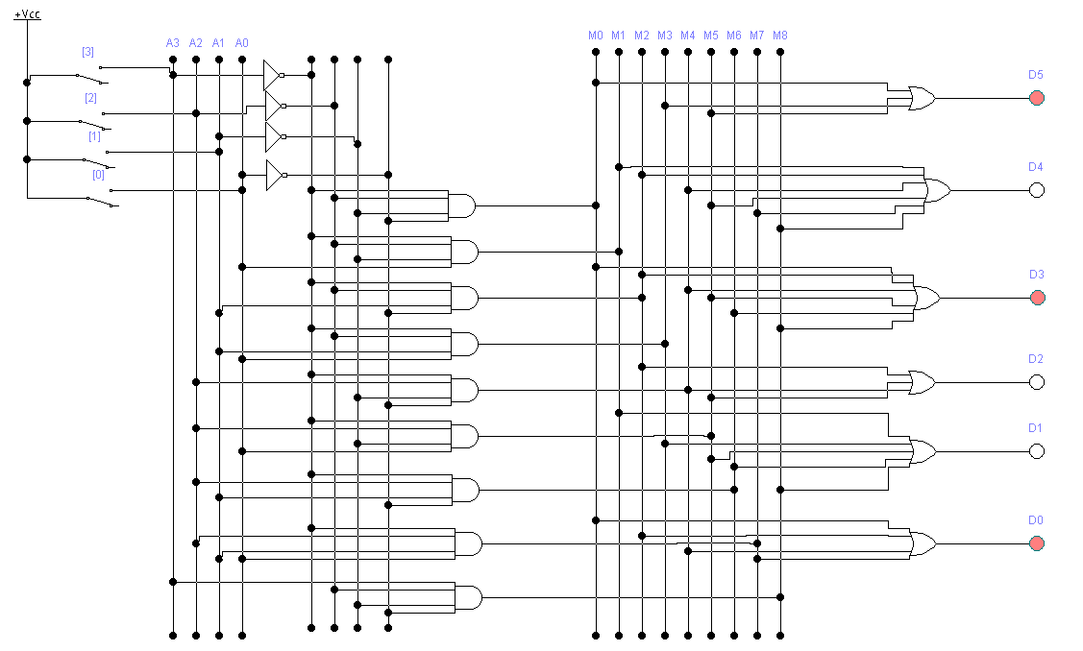

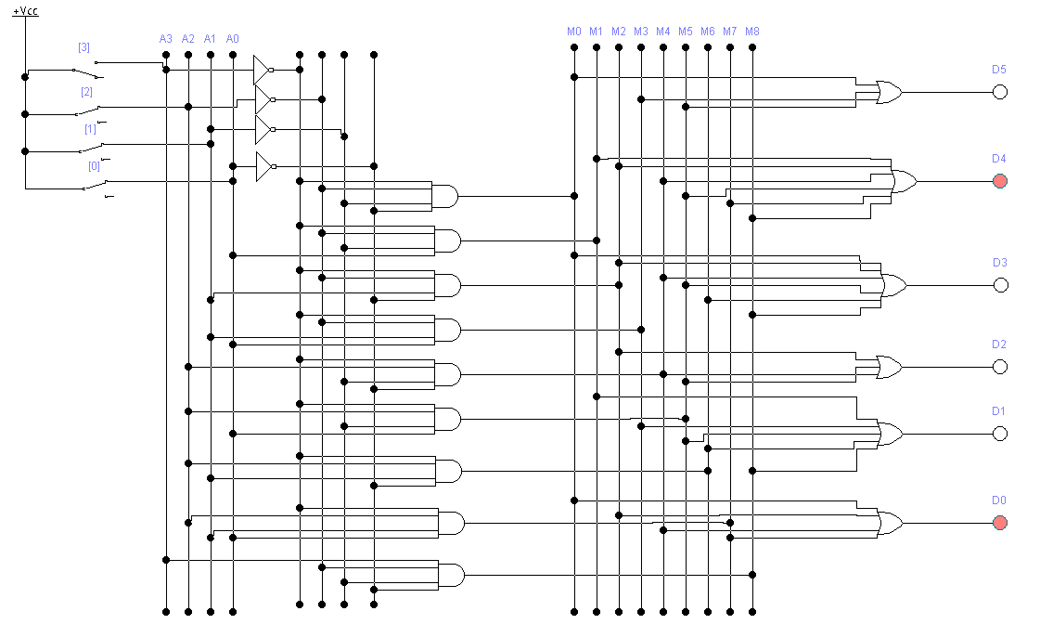

Fig. 3. Schema electrică a microcircuitului memoriei permanente